

NETWORK COMMUNICATIONS (SECR1213)
Section 04
Semester 01, 2025/2026

Network Design for Faculty of Computing Block N28B

Lecturer: Ts. Hazinah binti Kutty Mammi Group Name: TICH TECH
Group Members:

No | Name | Matric No
1 | SARAH HAMIZAH BINTI HASRAM | A24CS0296
2 | NURUL HUDA NABILAH BINTI ABDUL RAHIM | A24CS0176
3 | LUO CIMEI | A24CS4102
4 | AMR KHALED HASAN QATAB | A24CS4100

Report Abstract

Table of Contents
- Introduction 3
- Project Background and Overview 4
- Compiled Solutions of Task 1-5 5
TASK 1 5
TASK 2 15
TASK 3 16
TASK 4 17
TASK 5 18
- Conclusion 24
- Team Members and Responsibilities 25
- References 26
Appendices 27

Table of Figures
Figure 1:
Figure 2:
Figure 3:

Introduction

This project involves the design planning of a network infrastructure for the new Faculty of Computing Block N28B. This project applies concepts learned in the Network Communication course to a real world scenario that requires a reliable, secure, scalable and cost effective network solution. Acting as network consultants, our team is responsible for analysing requirements, designing the network architecture and proposing suitable technologies to support the academic and operational needs of the faculty.

The aim of this project is to design a network system that can support current teaching, learning and administrative activities while remaining flexible enough to accommodate future growth. The proposed network is intended to provide high-speed connectivity, efficient management and secure communication across all areas of the new building.

The scope of this project includes understanding user and organizational requirements, designing the physical building layout, selecting appropriate network and end-user devices, planning LAN and WAN connections and developing an efficient IP addressing scheme. This project also considers network performance, scalability, security, wireless connectivity and budget limitations.

The objective of this project is to design and propose a complete network solution that fulfills functional, technical and future requirements. This includes ensuring reliable connectivity for laboratories, learning spaces and common areas while supporting high-performance networking, secure access and ease of management. The project also aims to apply theoretical networking knowledge in a practical context and enhance teamwork and problem-solving skills.

Several assumptions were made including the availability of network devices within the assigned budget, the accuracy of projected growth provided in the case study and successful integration with the existing campus network infrastructure.

Project Background and Overview

The Faculty of Computing is experiencing growth in students, staff and teaching activities, increasing demands on its IT and network infrastructure. Current facilities are insufficient to support high-performance systems, digital platforms and specialised labs, prompting the construction of a new two-storey building.

The building will accommodate multiple computer labs, a hybrid classroom, a video conferencing room and a student lounge with wireless access. Labs such as the Cisco Lab and Embedded Lab require dedicated networking equipment and configurations for hands-on learning. The network must high-speed connectivity, handle heavy traffic, ensure security and scale to meet future growth without major redesign.

Budget considerations require careful selection of devices, cabling and addressing schemes to balance cost, performance and reliability. This project presents a network design tailored to the faculty’s floor plan and lab layout, addressing current challenges while supporting long term academic needs.

Compiled Solutions of Task 1-5

TASK 1

Introduction

This project focuses on the initial stage of planning a network system for the new Faculty of Computing building. In this task, our group is required to form a team, study the case study, and design a suitable floor plan that meets the project requirements. The design aims to provide a clear layout for all building areas such as labs, hybrid classroom, video conferencing room and student lounge.
This task helps the team to understand how space planning relates to network design, ensuring that every area is efficiently arranged to support smooth connectivity and future expansion. By working together and applying appropriate design methods, our group developed a realistic floor plan that serves as the foundation for the upcoming network planning tasks.
Moreover, all floor plans in this report were created using Draw.io software. Below is the calculation of the final scale ratio used.

Real building size Width: 30 m = 3000 cm
Height: 20 m = 2000 cm
3000 ÷ 200 = 15 cm (so to fit on A4 paper)

The overall building layout, which measures approximately 30 metres in length and 20 metres in width, was drawn to a scale ratio of 1:200. This means that 1 centimetre on the floor plan represents 2 metres in actual size. The chosen scale allows the entire building, including all labs, classrooms, and facilities, to fit proportionally within the page. The 1:200 ratio provides a clear and readable representation suitable for analysis and network layout planning.

Floor Plan Design

Ground Level Floor Plan
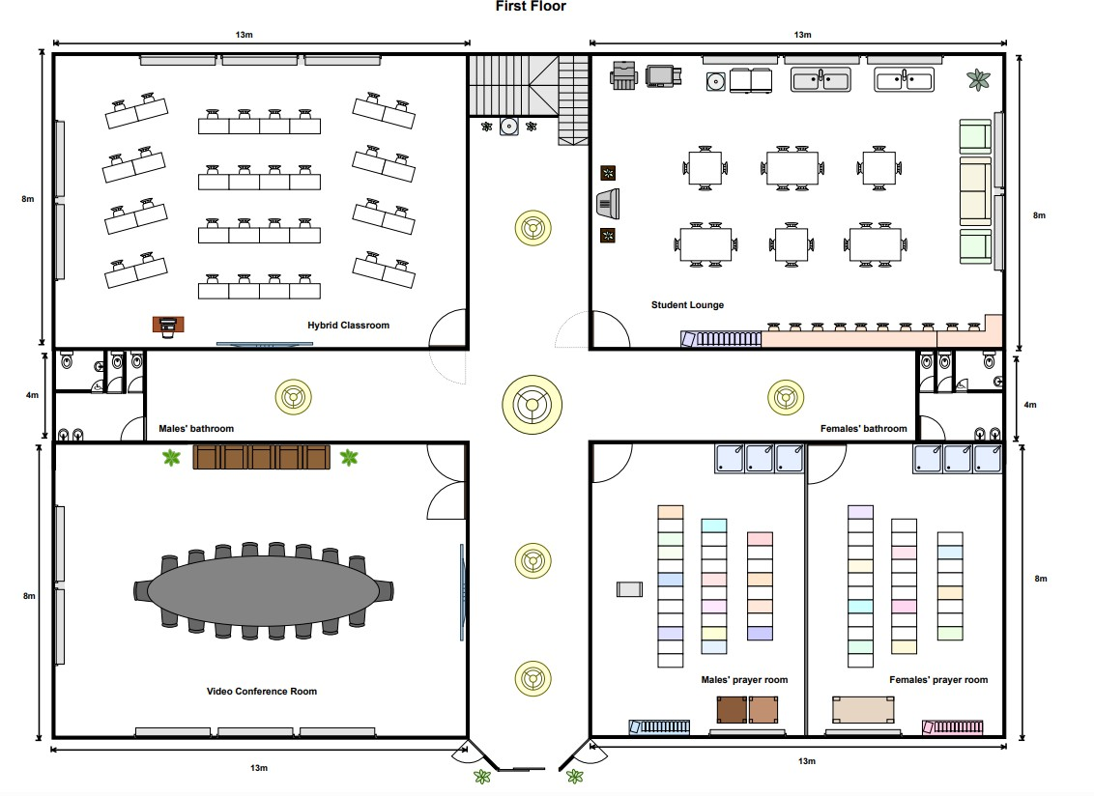
figure 2.1 Ground Level Floor Plan

The ground floor includes the Hybrid Classroom, Video Conference room, Student lounge, male and female prayer rooms, and male and female bathrooms. The layout is designed to support both learning and collaboration, providing flexible spaces for teaching and group discussions. The hybrid classroom and video conference room are positioned for easy access and efficient network connectivity, while the student lounge offers an open area for relaxation and study with wireless access. The placement of the prayer rooms and bathrooms ensures convenience and accessibility for all users.

First Level Floor Plan

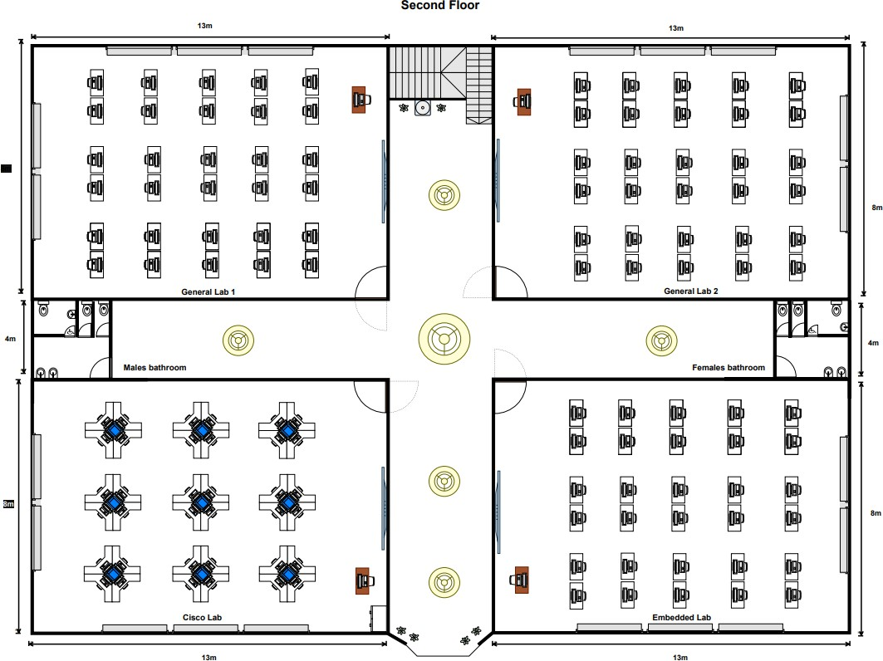
figure 2.2 First Level Floor Plan

The first floor consists of General lab 1, General lab 2, the Cisco lab and Embedded lab, along with male and female bathrooms. The labs are arranged to allow smooth traffic flow and efficient cabling between rooms. The Cisco lab is located for specialized networking activities, and the Embedded lab is set up for IoT and sensor-based experiments. Both General labs are designed for flexible use, suitable for various computing courses. This layout ensures a practical learning environment with sufficient space for a minimum of 30 workstations per lab and supports future network expansion.

Hybrid Classroom
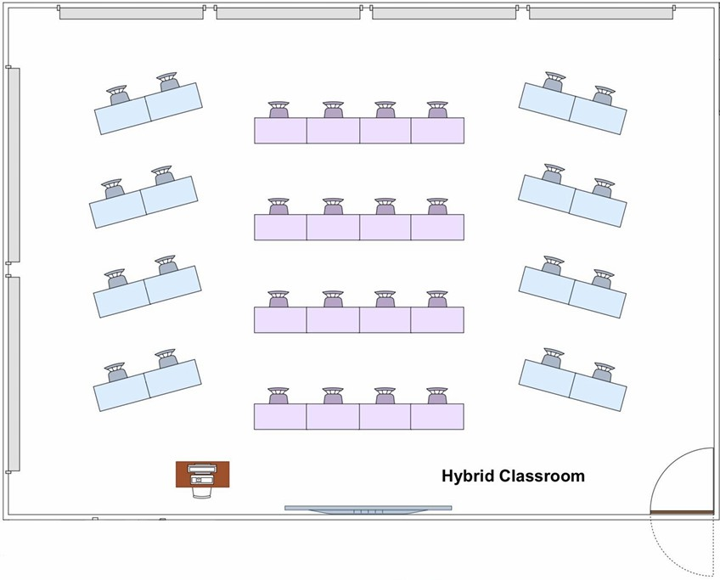
figure 2.3 Hybrid Classroom Floor Plan

The hybrid classroom supports both physical and virtual learning. It is equipped with video conferencing systems, interactive smart boards, wireless microphones and high-speed internet connectivity. This setup allows the lecturer to conduct face-to-face sessions while simultaneously connecting with remote participants. The design ensures high audio-visual quality and comfortable seating arrangements to enhance the teaching and learning experience.

Video Conference Room

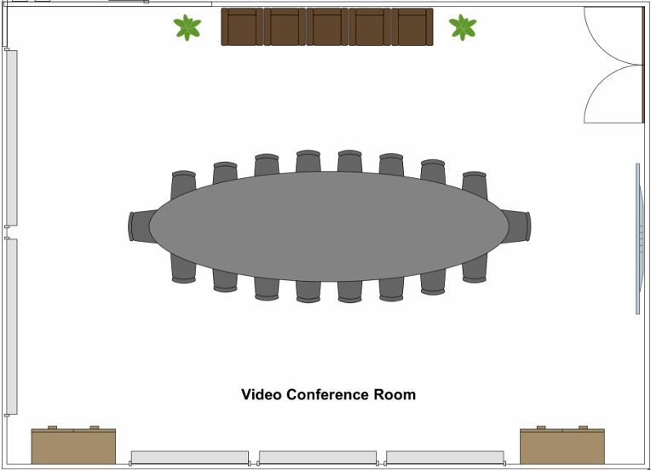

figure 2.4 Video Conferencing Room Floor Plan

The video conference room is built for virtual meetings, presentations and collaborative sessions. It includes high-definition cameras, conference microphones, a large display screen and reliable network connections. The room supports communication between staff, students and external partners, promoting remote project coordination, and academic discussions.

Student Lounge

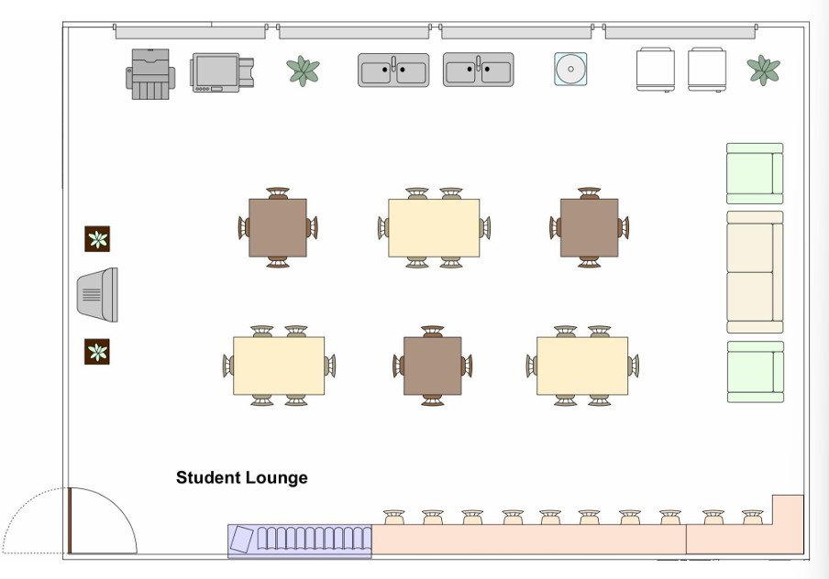
figure 2.5 Student Lounge Floor Plan

The student lounge provides a comfortable space for students to study, collaborate or relax. It is equipped with Wi-Fi access, charging ports and comfortable seating. The design encourages a social yet productive environment where students can engage in group discussions or individual work while staying connected to the faculty’s network.

Cisco Lab
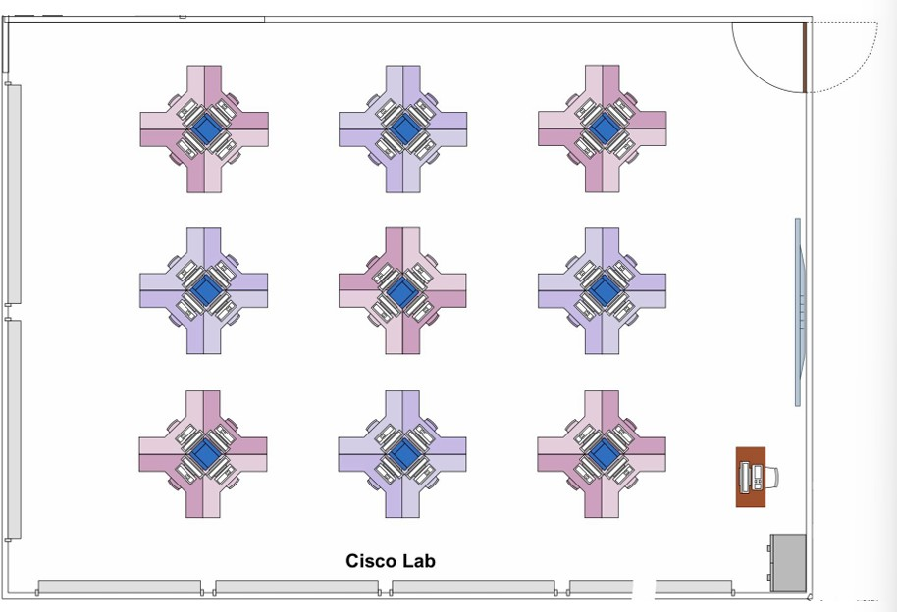
figure 2.6 Cisco Lab Floor Plan

The Cisco Lab is designed for network configuration, troubleshooting and implementation training. It includes 36 computer workstations, 9 Cisco routers and switches, patch panels and structured cabling systems to support hands-on networking activities. The lab is equipped with high-speed wired connections and secure access points for real-time simulation and testing. This setup supports the Faculty’s goal of preparing students for professional networking certifications and 4IR-related technologies.

Embedded Lab
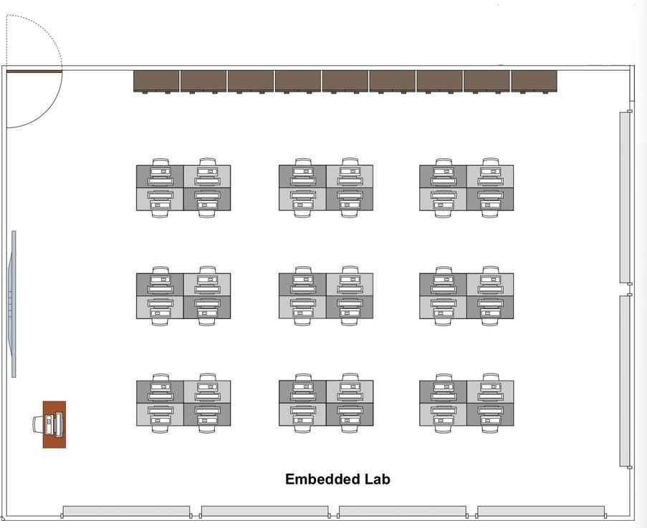
figure 2.7 Embedded Lab Floor Plan

The embedded lab focuses on IoT, digital systems, and sensor-based projects. It is equipped with development kits, microcontrollers, testing instruments and computers connected through a stable local area network. The lab provides both wired and wireless connectivity to allow students to integrate hardware and software systems efficiently. The arrangement ensures enough workspace for hardware setup and prototype testing.

General Lab
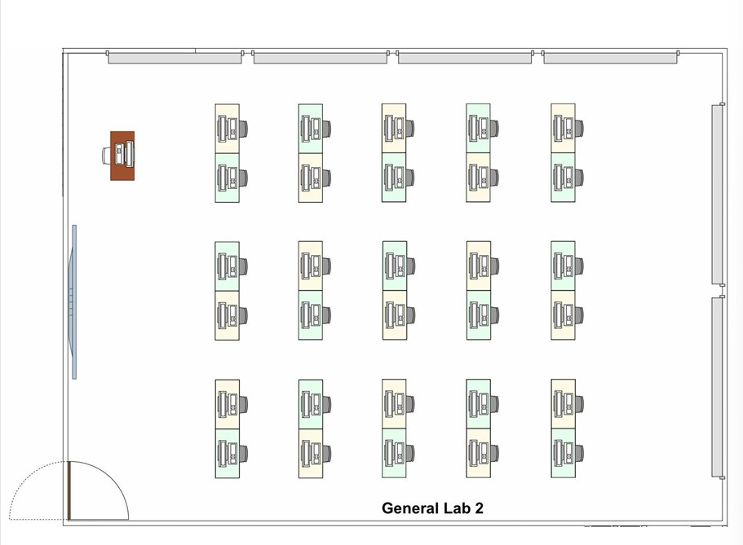
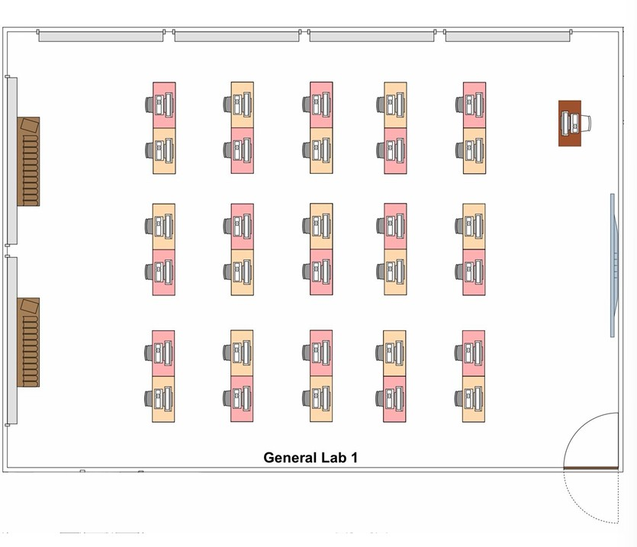
figure 2.8 General Lab 2 Floor Plan figure 2.9 General Lab 2 Floor Plan

The two General labs are designed for regular computing classes, programming and software-based learning. Each lab contains 30 computer workstations, projectors, network switches and Wifi access. The layout allows easy movement and clear visibility for both students and instructors. The network infrastructure ensures high-speed internet access for online learning, research, and lab exercises.

Reflection Task 1

Through this task, we learned that the placement of rooms and labs within a building directly affects network efficiency, usability and management. By placing the hybrid classroom, student lounge and video conferencing room on the ground floor, we understood how shared and high traffic area benefit from easy access and strong wireless coverage. These spaces are frequently used by different group and often involve guest access or flexible usage. This making them more suitable for the ground floor where network access points can be optimised for wide coverage rather than specialised configurations. Placing General lab 1, General lab 2, Cisco lab and Embedded lab on the first floor allows for more structured cabling, easier device management and better security. This make it easier to manage when they are located together. We also learned that this arrangement simplifies troubleshooting, supports consistent performance across labs and allow future upgrades to be implemented without disrupting public or shared spaces.

Lastly, we learned that an efficient layout is not only about current usage but also about long term maintenance and scalability. Separating general use areas on the ground floor and specialised labs on the first floor allows network to be expanded or upgraded without affecting unrelated areas.

TASK 2

Questions

    - What specific devices and equipment will be used in specialized labs, such as the Cisco Network Lab?
In the Cisco Networking Laboratory, the specific device that may be used in Cisco Network Lab is Raspberry Pis. Raspberry Pis functions as versatile access nodes and interfaces, connecting students to Cisco Devices (Shakya et al., 2016). These small computers enable students to configure and manage the Cisco network equipment, making learning practical and interactive. Simultaneously, Cisco Devices form the core of the wireless network, including routers, switches, and access points. Connected to Raspberry Pis, they provide hands-on experience for students to apply theoretical knowledge to real-world networking scenarios, preparing them for careers in the field. Together, Raspberry Pis and Cisco Devices create a dynamic learning environment in the lab.

What is the suitable router type for each of the laboratories?

Router is a vital device in creating a powerful Local Area Network (LAN). It is a device that connects LAN with the Internet Service Provider (ISP) or Wide Area Network (WAN). In our new academic building, we use 2 in 1 modem routers. This kind of modern network infrastructure provides end users a better internet experience and connectivity as it improves signal strength and transfer rates. In our new academic building, there will be four interconnected routers which are placed at the server room. This enables the construction of a stronger subnet within the building.
There are several types of routers that are suitable for creating a networking infrastructure. First, the cable modem is one of the powerful modems that allows anyone to access the internet anywhere. In research (Choudhary, 2022), since it is not a dial-up connection, which requires you to disconnect from the Internet to receive and make calls on your landline, the Internet is also accessible around the clock. In comparison to DSL satellite, dial-up, and satellite connections, cable modems provide higher Internet speeds.

Large file download and upload times are accelerated by cable modems. In contrast to dial-up connections, cable modems are less susceptible to dropping out or losing connection.
The second type of router is Digital Subscriber Line (DSL) modem. DSL is quicker than dial-up and allows users to select between various connection speeds and provider pricing. (Diffen, n.d.) It also gives users access to the Internet and a phone line simultaneously. Cable delivers performance that is quicker than both dial-up and, most likely, DSL and is not dependent on the distance from a provider's central location.

What type of network cable is the most appropriate for connecting the computers, and what are the reasons for selecting it?
The most appropriate network cable for connecting computers is a Cat6 Ethernet cable. They offer speeds up to 1 Gbps, sufficient for most educational applications, and provide a good balance between performance, distance (up to 100 meters without signal degradation), and cost (Mitchell, 2019). Additionally, Cat6 cables have better shielding against electromagnetic interference, which is common in school environments with numerous electronic devices. Their compatibility with existing network standards and a degree of future-proofing for potential network upgrades make them a practical and efficient option for educational settings (Luciaclemares, 2023). Lastly, it is cost-effective and widely available, making them a practical choice for networking needs (Martindale, 2019).

What are the required specifications for high-speed internet connections in the labs, classrooms, and video conferencing rooms to support the computing needs?
The required specifications for high-speed internet connections include a bandwidth management system featuring advanced functionalities, such as time allocation for service usage, offers the capability to assign dedicated bandwidth and specific time slots to individual users, enhancing the overall network experience. (Sawehli et al., 2020) Through dynamic bandwidth allocation, the system can adapt and allocate varying bandwidth based on user profiles and needs, ensuring that critical users receive the

necessary resources while efficiently utilizing network capacity. (Sawehli et al., 2020) This approach guarantees a reliable internet connection speed, which is particularly crucial in densely populated areas where many users are accessing the network simultaneously. These systems, which govern and regulate the dedicated bandwidth provided by internet service providers (ISPs), play a pivotal role in optimizing network performance, making them integral components for ensuring a seamless and high-quality online experience for users. This setup enables the establishment of a high-speed internet connection that can handle multiple users concurrently, enhancing the overall network performance.

What are the key considerations when planning the network infrastructure for a large academic building like the Faculty of Computing?
The key considerations include the requirements for indoor wireless network coverage (Sawehli et al., 2020), which will dictate the number and positioning of access points (APs) within the facility. Factor in the expected number of devices (Sawehli et al., 2020), such as laptops, that will connect to the network to ensure efficient operation. Additionally, plan for overlapping wireless coverage in outdoor areas (Sawehli et al., 2020) by establishing multiple base stations, ensuring seamless wireless connectivity across the entire floor of the building. Consider the room sizes and strategic position access points, including options like ceiling-mounted devices, to preserve signal strength. Lastly, carefully select and deploy the appropriate wireless network equipment (Sawehli et al., 2020), such as the company's MSR, tailored to the specific needs of various academic buildings, including the main building, laboratory building, office building, and student lounge, to achieve comprehensive and reliable network coverage.

Should each lab support group-based learning ( collaborative tables, shared screens) or individual workstation ?
According to Ms. Hazinah Kutty Mammi, the Faculty representative, each lab in the Faculty of Computing should be designed with individual workstations rather than group-based collaborative tables, as this setup best supports the hands-on and technical

nature of computing courses such as programming, networking and embedded systems. These subjects require students to perform independent tasks like coding, configuring network devices and testing hardware components, which demands full control over personal computers and dedicated resources. Individual workstations ensure that every student can customise their software environment, work efficiently and develop personal problem-solving and technical skills. This layout also promotes fairness and academic integrity during assessments while simplifying lab management and maintenance. Although the workstations are designed for individual use, collaboration can still be achieved digitally through shared network drives, cloud platforms or online tools, providing flexibility for both individual and group activities.

How to ensure network security?

Network security is essential to prevent the miscellaneous attack from the hacker to get into the LAN or to achieve Denial-of-Service (DoS) on the server. To defend such attack, there is some prevention or defensive action can be taken from the software perspective (Rojas, 2014). The first action to enhance software security is to install a firewall. Firewall can play a role of first-line defence against all type of attack and control unauthorized access to the computer or internet that will harden the ability of the attacker to sneak into the LAN. The second action is to install a web-filtering. The purpose of web-filtering is to prevent the device attached to the LAN from surfing unwanted website such as dark web that student will always enter it out of curiosity or to get some illegal information or product from it. Besides, the web-filtering also can prevent the devices to search for adult-content that mostly at high-risk of containing malware from the attacker. Apart from the advantage of the security, web-filtering also can block the surfing of Facebook and social media and game to maintain a high quality and efficiency studying environment.

What tools and techniques can be used for real-time monitoring and management of the network to ensure high availability and performance?
To ensure high availability and performance, one of the methods is to utilize network monitoring tools like ManageEngine OpManager (ManageEngine, 2019). These tools can track network devices, servers, switches, routers, and more in real-time, providing insights into network performance. Secondly, monitoring real-time performance metrics such as bandwidth usage, latency, packet loss, and network traffic (Lamberti, 2023). These metrics help identify issues as they occur and allow for prompt troubleshooting. Besides that, leverage network monitoring tools that offer customizable widgets and real-time performance graphs to visualize network data effectively and troubleshoot problems efficiently (Lamberti, 2023).

What are the key requirements for a high-quality video conferencing room in terms of network connectivity and hardware?
The key requirement for a high-quality video conferencing room is having a high-resolution webcam. This is because high-quality video conferencing relies on capturing and transmitting subtleties such as facial expressions and body language. When these details are lost, the authenticity of meetings diminishes, lacking the nuances of in-person interactions (Writer, 2020). The second one is sufficient network bandwidth. The amount of internet strength needed depends on how clear you want the video to be. For instance, if we want a moderate quality video at 720p resolution with 15 frames per second, we will need about 1 Mbps. However, for a higher quality video at 4K resolution with 30 frames per second, we would need roughly 4 Mbps. Also, if many people join the video call, more internet strength will be necessary. Even if our Wi-Fi is good and reaches throughout the building, having lots of people on the call will demand more internet power. (Writer, 2020)

How to set up a LAN?

Before setting up the network, it is necessary to identify the local services and number of devices that are going to connect to the internet. A unique address is required for each server, devices, and workstation. To determine the distance for all hardwired devices, run a cable to servers or any possible working area. (Angelina Twain, 2016) Next, prepare a standard Ethernet cable and gather all the devices needed especially router and switch. Configure the WAN and LAN ports of the router. Make sure the address pool has enough addresses for all the workstation. After that, connect the wire for the network. Use a standard Ethernet cable to connect workstations and servers. Connect the switch to the router LAN port by using a straight port on the switch. Last, connect the access point to the router via Ethernet cable. Test the internet connectivity with each of the workstations, printers, and servers. (Kim Staples, 2017)

Feasibility Assesment

Technical feasibility

The technical feasibility of the proposed Faculty of Computing upgrade is highly achievable, as all required devices, network technologies and infrastructure components are readily available and compatible with current educational and industrial standards. Modern computing and networking equipment such as high performance desktop computers, network switches, routers, wireless access point and IoT devices. These are widely available from established vendors like Cisco, HP and Dell. The proposed setup, which includes four specialized labs called General labs, Cisco lab and Embedded Lab and one hybrid classroom and one video conferencing room can be efficiently supported using Gigabit Ethernet (1 Gbps) or 10 Gigabit Ethernet (10 Gbps) backbone network, which are standard in current academic environments. These technologies are fully compatible with structured cabling systems and Wifi standard, ensuring high-speed and low-latency connectivity.
Additionally, the integration of security measures such as firewalls, network access control (NAC) and antivirus gateways is technically feasible and can be implemented using existing network management tools and security appliances. The embedded lab’s IoT and sensor-based learning components can be easily supported using microcontrollers and wireless communication modules that integrate seamlessly into the same network infrastructure. Overall, the proposed system is technically feasible, scalable and compatible with the university’s current and future technologies ecosystem.

Operational feasibility

Operationally, the project is feasible. The proposed network can be managed effectively by existing IT staff once training is provided. A centralised network monitoring system will allow administrators to configure, monitor, and troubleshoot devices efficiently.
The design supports the daily operations of different users within the faculty. For example, students will have stable and secure Wi-Fi connection and wired access throughout the labs and the student lounge and lecturers will have access to dedicated VLANs that is flexible for teaching and online conferencing. Administrative staff will also benefit from a steady and high-speed connection for documentation, scheduling, and communication systems.
In addition, maintenance will be scheduled outside of class hours to minimise disruption for students and staffs. Proper documentation and standard operating procedures will be recorded to ensure smooth operation and troubleshooting in the future. Security measures such as firewalls, authentication systems, and antivirus softwares will protect sensitive data such as student records and internal files. These implementations show that the project can operate efficiently and securely on a day-to-day basis.

Economic feasibility

The project conducts economic feasibility analysis in terms of budget rationality, operation and maintenance cost control and long-term investment value.

- Budget rationality
The allocated budget is for this project is RM1,600,000 and it is in line with the scale and functional requirements of the new teaching building, which can fully guarantee the necessary network infrastructure and installation funds while avoiding unnecessary expenses, thus keeping the budget reasonably within an acceptable range

- Operation and maintenance cost control
The school has its own IT department. After training, IT staff can operate and maintain the system independently without relying on external services, reducing operating and maintenance costs.

- Long term investment value
The network design for this project prioritizes long-term reliability and sustainability. The selected equipment is durable and of high quality, reducing the need for frequent replacements or repairs. Although the project requires a large initial investment, this design lowers operating and maintenance costs, so it increasing long-term return on capital. Furthermore, a stable and secure network can lead to greater educational benefits and improve student and staff satisfaction.

Overall, the project demonstrates high economic feasibility. The project budget is within acceptable limits, operating and maintenance costs are effectively controlled, and the design reflects long-term value in terms of resource utilization and system reliability. The project is both cost and operational efficiency, and will bring economic and educational benefits to the school.

Schedule feasibility

The network can be developed and implemented within the given project timeline. The new building and network upgrade is considered realistic and achievable provided that proper planning, coordination and phased implementation are followed. All required devices such as routers, switches, and access points are readily available in the market, and the installation process can be completed efficiently through proper planning. This schedule is also supported by the fact that all required network devices and computing equipment are commercially available and can be sourced from established vendor without long lead times. The building structure and layout are simple, allowing the setup to be done in stages without delays. Therefore, no major issues are expected, and the project is time-feasible within the scheduled duration.

Reflection Task 2

Working on Task 2 as a group allowed us to combine our ideas and technical knowledge to plan the network infrastructure for the Faculty of Computing. We collaboratively identified the devices and equipment needed for specialized labs, designed lab layouts with individual workstations, and considered the best network connections, routers, and high-speed internet requirements to ensure reliable and efficient performance.
This task also helped us understand the importance of feasibility analysis in network design. We learned that a network does not only need to work technically, but it must also be realistic in terms of cost, daily operation, and time constraints. Through this task, we realised that technical, operational, economic, and schedule feasibility are closely related. From the technical feasibility analysis, we understood the value of using standard and reliable devices to ensure stability and ease of implementation. Operational feasibility helped us think about daily usage, maintenance, and how the network would be managed by IT staff. Economic feasibility was one of the more challenging parts, as we had to consider budget limits while still meeting performance requirements. Schedule feasibility also showed us that good planning is necessary to complete a project on time. Overall, this task helped us think more realistically about network planning instead of focusing only on technical features.

TASK 3

List of Devices

Router

Model | 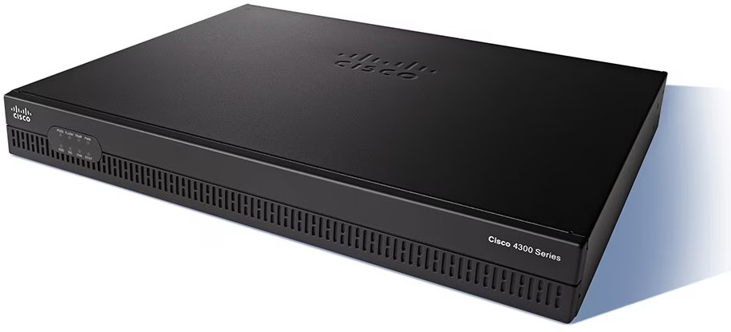  Cisco ISR 4321 | 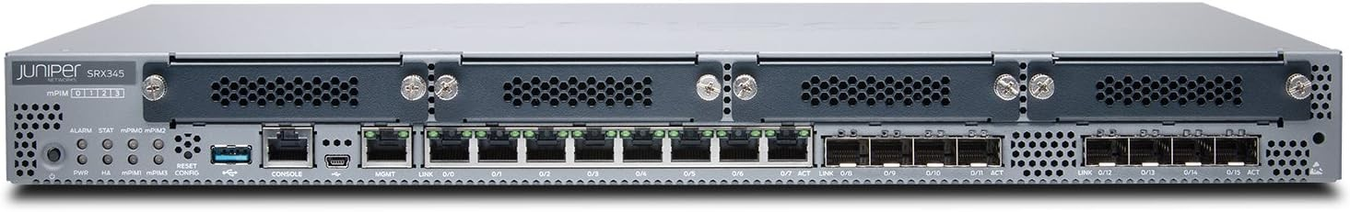  Juniper SRX345 | 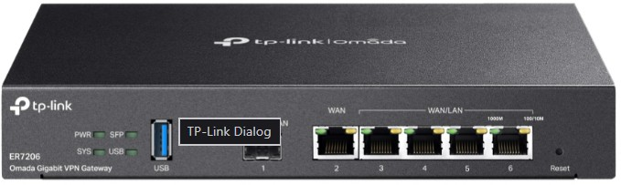  TP- Link TL-ER7206
Throughput | 100-300 Mbps | Up to 5 Gbps | Up to 1.8 Gbps
WAN options | 2x Gigabit | 4x Gigabit | 4x Gigabit
LAN ports | 2x 1GbE | 16x 1GbE | 4x 1GbE
Security Features | Bisac (Firewall, VPN, IPS) | Strong (Firewall, VPN, IPS/IDS, Threat Protection) | Bisac (Firewall, VPN, IPS)
Scalability | Limited expansion | Highly expandable | Limited expansion
Redundancy | No | Yes | No
Management | Cisco IOS XE | Junos OS | Omada SDN os
Price (RM) | 4764.11 ( Link ) | 9533 ( Link ) | 580 ( Link )
Reference | More information | More information | More information

Reason for Choosing Juniper SRX345:

The Juniper SRX345 is the best router option due to its high throughput, extensive LAN/WAN ports, and redundancy, supporting many devices reliably. Its advanced security features and scalable design make it ideal for an academic network with labs, classrooms, and video conferencing rooms. Although it is more expensive, it offers long-term performance, reliability, and easier management, making it a worthwhile investment.

Core Switches

Model | 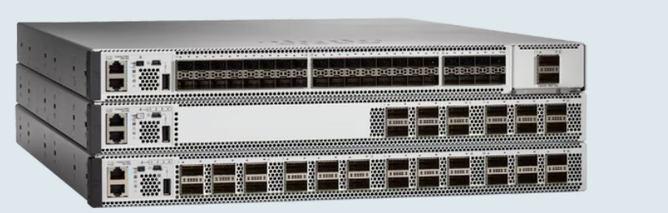  Cisco 9500-24Y4C | 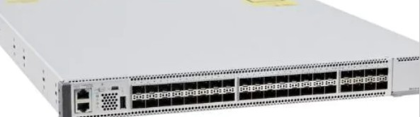  Cisco Catalyst 9500-40X | 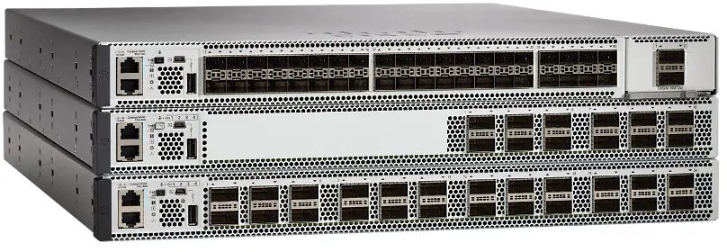  Cisco Catalyst 9300
Throughput | Up to 1.7 Tbps | Up to 3.2 Tbps | Up to 208 Gbps
Port | 24 × 25GbE (SFP28)  + 4 × 100GbE (QSFP28) | 40 × 100GbE (varies per model) | 24/48 × 1GbE + 4 ×  10GbE uplinks
Stackable | YES | YES | YES
Layer | 3 Layer | 3 Layer | 3 Layer
Reliability | Very high | Ultra high | High
Price (RM) | 15044 ( Link ) | 31021 ( Link ) | 15000 ( Link )
Reference | More information | More information | More information

Reason for Choosing Cisco 9500-24Y4C:
The Cisco 9500-24Y4C was selected because of its high switching capability, Layer 3 capabilities, can work perfectly with our router (Juniper SRX345) and excellent backbone stability. It provides fast and secure connectivity, supports advanced routing, and is ideal for scalable campus networks.

Access Switch

Model | 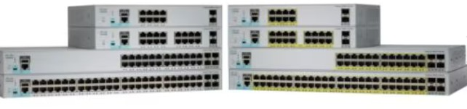  Cisco Catalyst 2960-L | 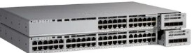  Cisco Catalyst 9200 | 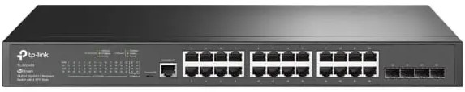  TP-Link TL-SG3428
Ports | 24/48 × 1GbE + 2×  1GbE uplinks | 24/48 × 1GbE + 4 ×  10GbE uplinks | 24 × 1GbE + 4 ×  SFP uplinks
Switching speed | Up to 56 Gbps | Up to 176Gbps | Up to 56 Gbps
Stackable | No | Yes | No
PoE option | Available | Available | unavailable
Reliability | Medium | High | Low
Price (RM) | 1170 ( link ) | 98200 ( link ) | 824 ( link )
Reference | More information | More information | More information

Reason for Choosing Cisco Catalyst 9200:
The Cisco Catalyst 9200 was chosen for its stable performance, fast uplink support, and enterprise-class reliability. It provides robust access layer connectivity, supports 10Gb uplinks, and is suitable for high-density academic environments.

Wireless Access Point

Model | 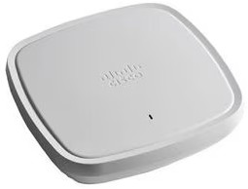  Cisco 1850 / 9115AX |   Ubiquiti UAP- AC-Pro | 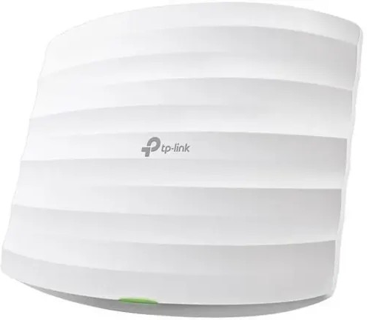  TP- Link EAP245
Speed | Up to 1.7 Gbps | Up to 1.3 Gbps | Up to 1.75 Gbps
Users | 50 - 70 Users | 40 - 50 Users | 30 - 40 Users
WIFI Stander | WiFi 6 | WiFi 5 | WiFi 5
PoE | Yes | Yes | Yes
Price (RM) | 2207 ( Link ) | 617 ( Link ) | 399 ( Link )
Reference | More information | More information | More information

Reason for Choosing Cisco 1850 / 9115AX :
The Cisco Aironet 1850/9115AX was selected for its high-speed WiFi performance, powerful user capacity, and enterprise wireless features. Supports WiFi 6 technology, provides reliable coverage, and is suitable for dense academic areas.

Firewall

Model | 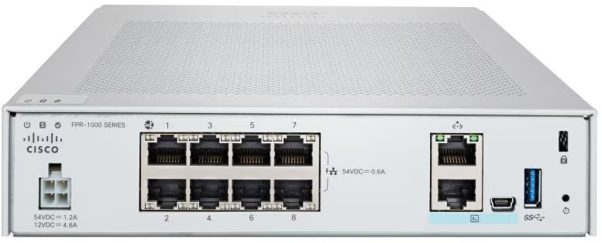  Cisco Firepower 1010 | 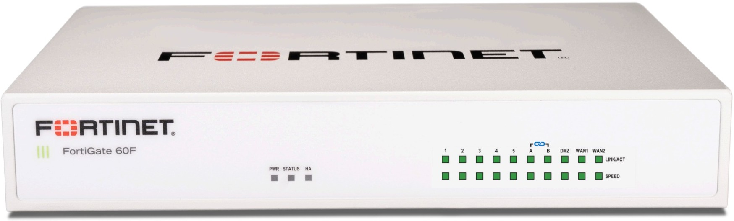  Fortinet FortiGate 60F | 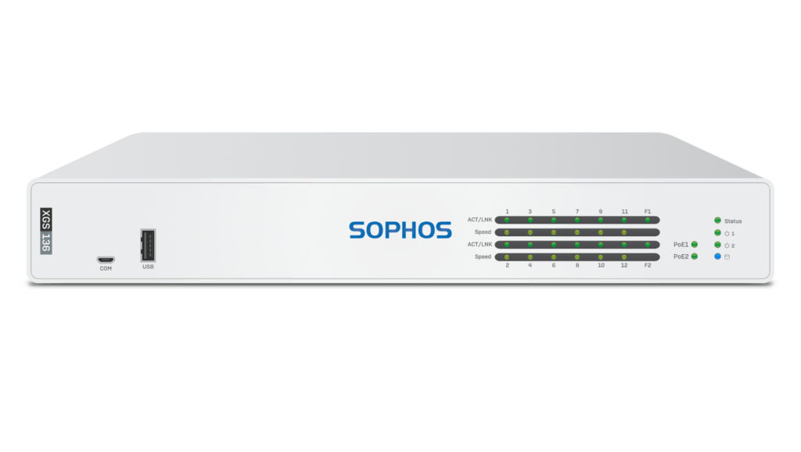  Sophos XGS 116
Throughput | 2 Gbps | 10 Gbps | 6.5 Gbps
Threat Protection | Advanced | Advanced | Advanced
Price | Higher | Medium | Medium

Reason for Choosing Cisco Firepower 1010:
The Cisco Firepower 1010 was selected for its advanced threat protection, integrated VPN capabilities, and ease of deployment. It provides strong network security for small to medium environments, making it suitable for securing academic networks.

Camera

Model | 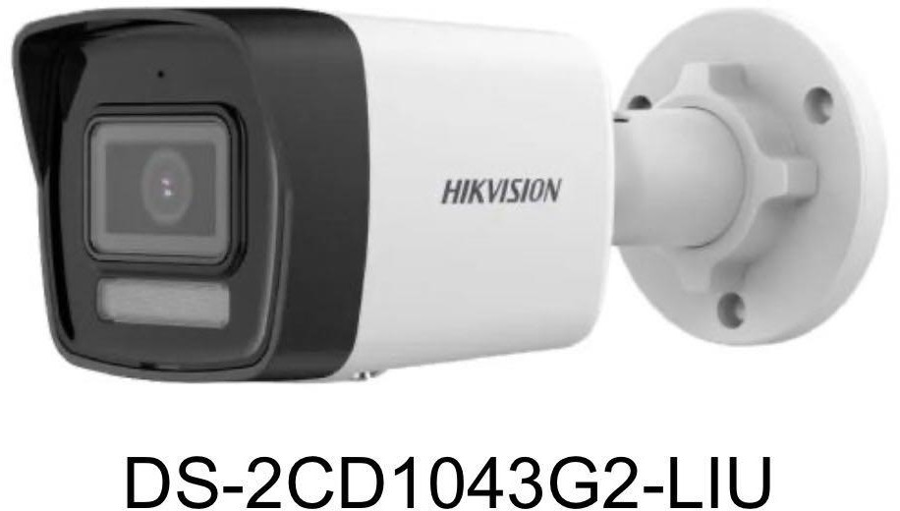 | 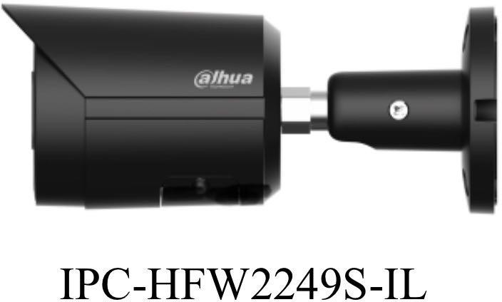 | 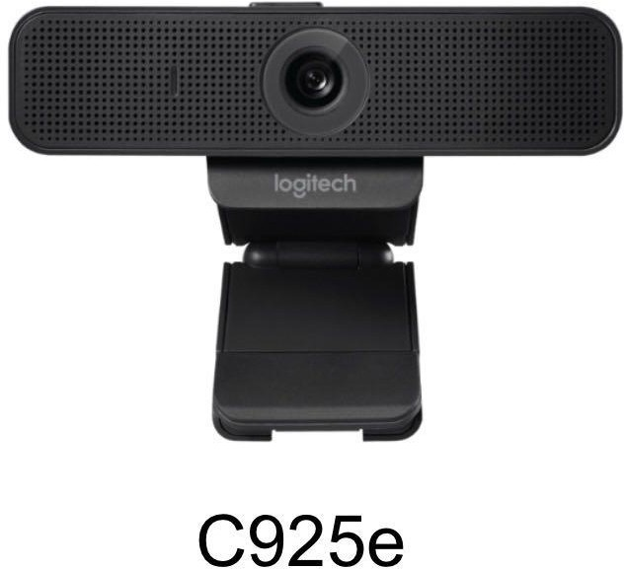
Max resolution | 4MP(2560x1440) | 2MP(1920x1080) | 1080P(1920X1080)
Min illumination | 0.005 lux(color 0 lux with IR | 0.002 lux (color) 0.0002(B/W)  0 lux with IR | RightLight(low-light)
Field of view | H98°,V54°,D114° (2.8mm) | H107°,V56°,D127° (2.8mm) | D78°(fixed)
Price (RM) | 329.00 (Link) | 476.00(Link) | 595.00(Link)
Reference | More information | More information | More information

Reason for choosing Hikvision(DS-2CD1043G2-LIU):
Compared to the other two,the Hikvision offers a higher resolution(4MP). Although its field of view and min illumination are slightly narrower than Dahua(IPC-HFW2249S-IL), it is more affordable. The Logitech(C925e), however, has a fixed viewing angle , so it's not suitable for use in a lab or classroom.

- Projector

Model |  | 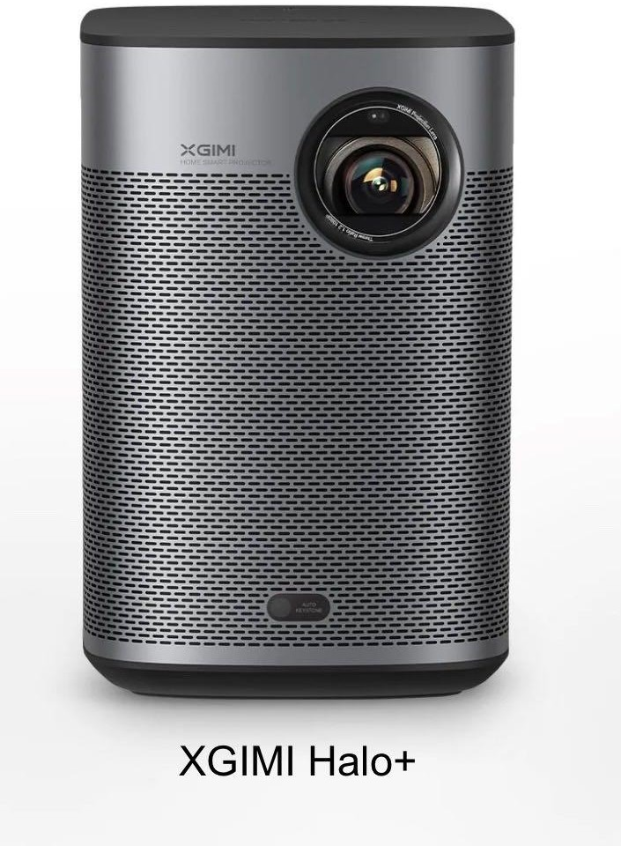 | 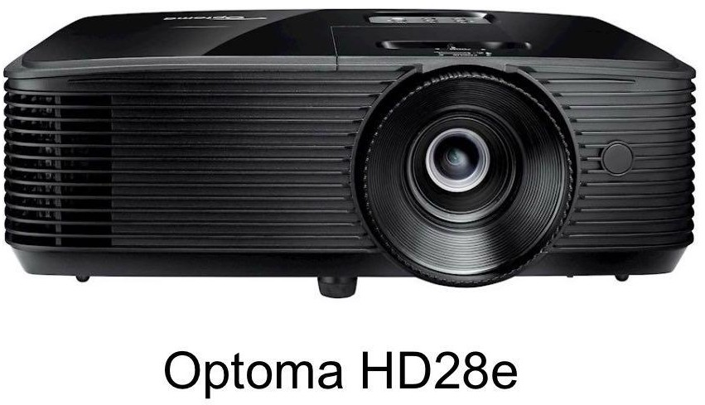
Resolution | 4K(3840X2160) | 1080p(1920x1080) | 1080p(1920x1080)
Brightness | 2200(ANSI lumens) | 700(ISO lumens) | 3800(lumens)
Light source life | 4000 hours(normal)  15000 hours(Smart ECO) 10000(ECO) | 25000 hours | 15000 hours
Price (RM) | 8971.00 (Link) | 3277.50 (Link) | 2909.00 (Link)
Reference | More information | More information | More information

Reasons for choosing Optoma(HD28e):
Although BenQ(W2710i) delivers the best performance, its price is too high. Compared to XGIMI(Halo+), Optoma has a shorter lifespan, but it offers the same resolution, higher brightness, and a more affordable price. Therefore, Optoma provides a better balance between cost and performance.

Screen

Model | 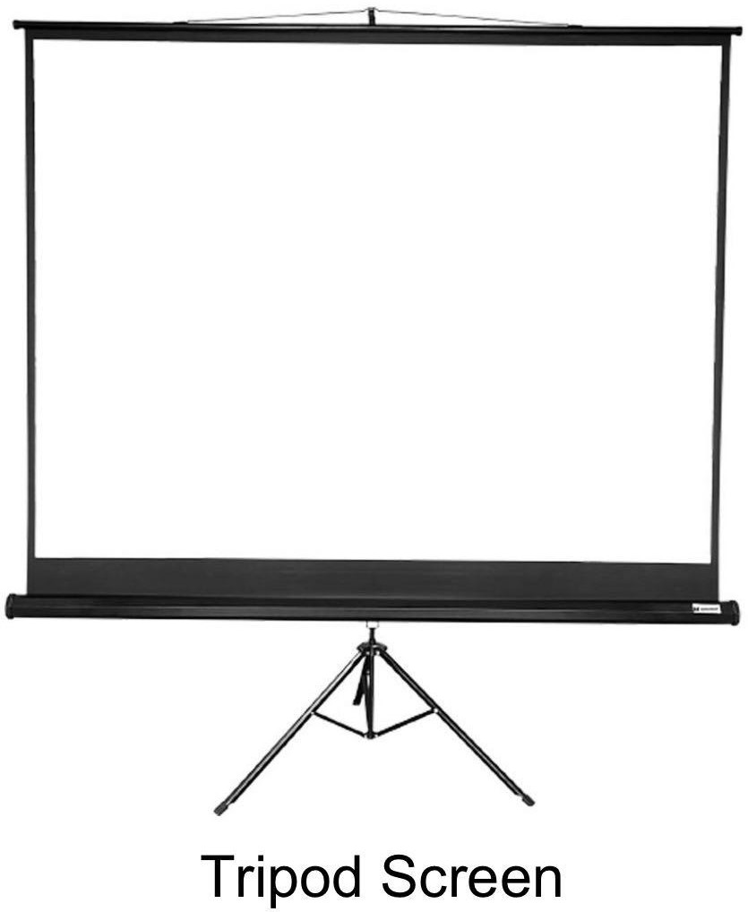 | 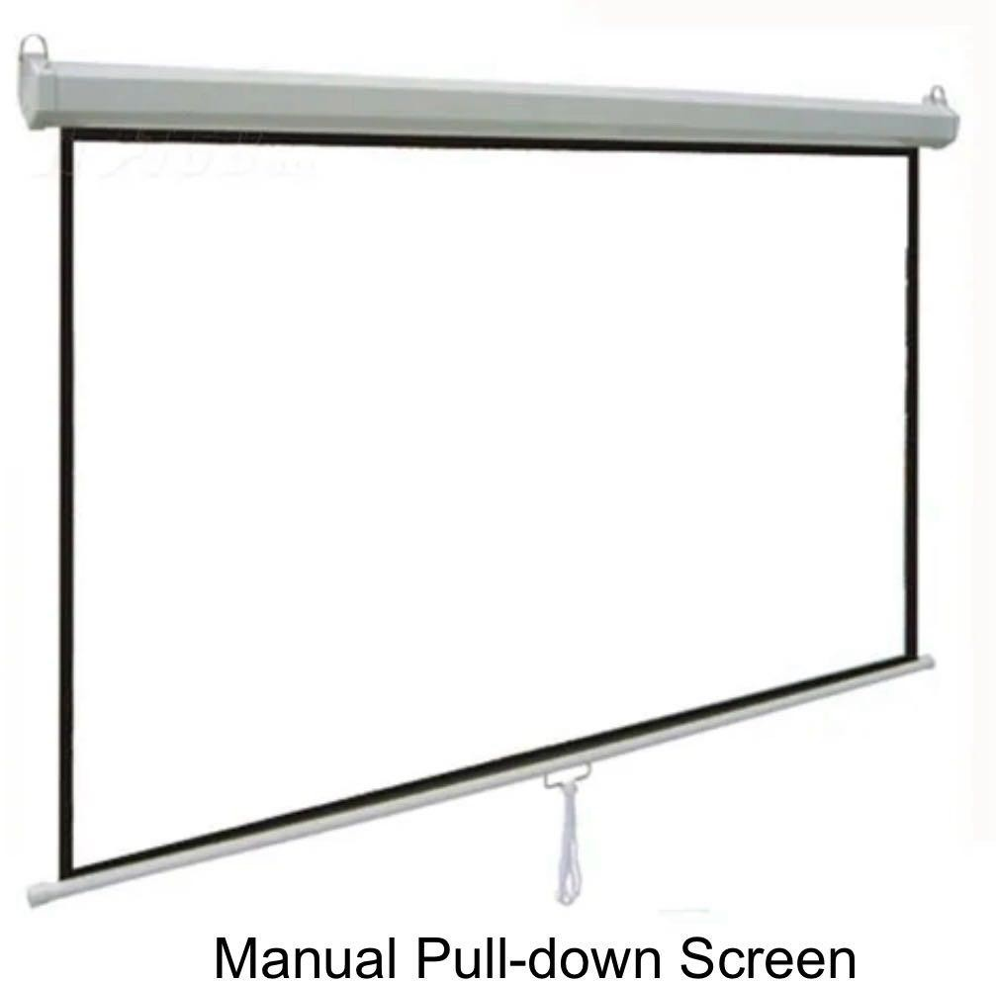 | 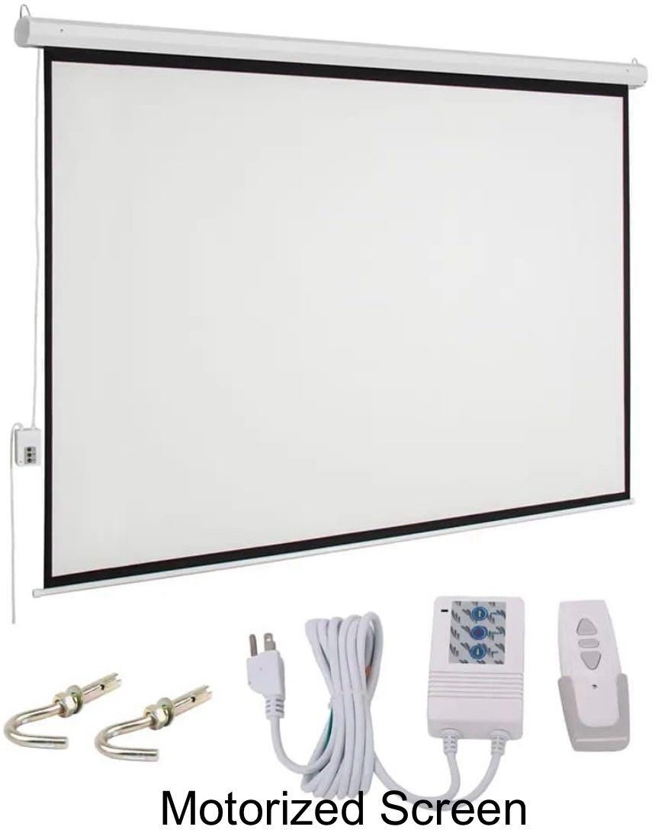
Screen type (120 inches) | Tripod screen | Manual pull-down screen | Motorized screen
Price (RM) | 161.92 (Link) | 216.76 (Link) | 407.83 (Link)

Reasons for choosing Manual pull-down screen:
Although Tripod screens are cheaper, they may be less stable. Manual pull-down screens are not as concvenient as motorized screens, but they are more affordable. Therefore, a manual pull-down screen provides a better price.

Printer

Model | 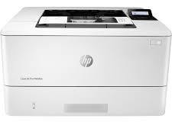  HP LaserJet Pro M404dn | 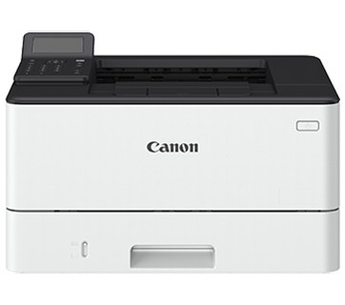  Canon imageCLASS LBP226dw | 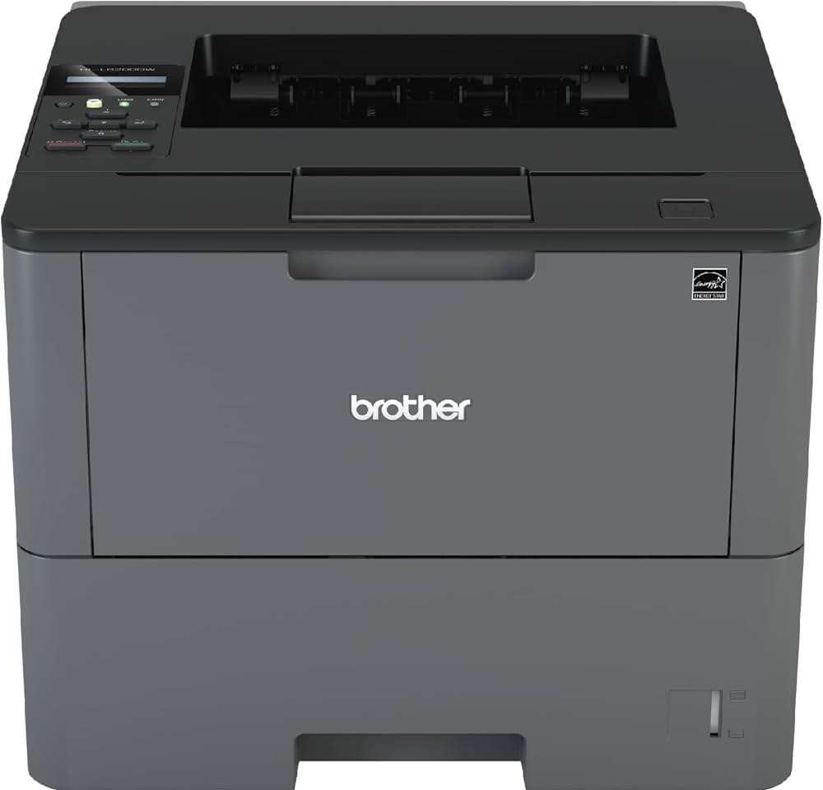  Brother  HL-L6200DW
Speed | 40 ppm | 38 ppm | 48 ppm
Duplex printing | Yes | Yes | Yes
Energy Efficiency | High | High | Moderate
Price (RM) | 1500 | 1200 | 1800

Reasons for choosing HP LaserJet Pro M404dn:
Its high-speed printing, energy efficiency, and reliability, which are critical for the usage for many students. The Canon imageCLASS LBP226dw is more budget-friendly but offers slightly lower speed. The Brother HL-L6200DW has the fastest speed but is more expensive and less energy-efficient.

IOT Device

Models | 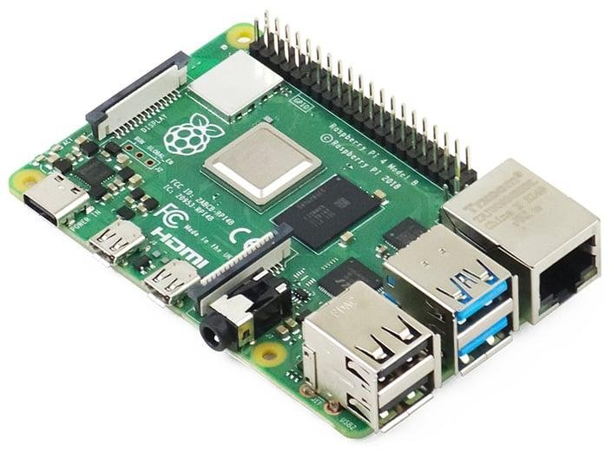  Raspberry Pi 4 | 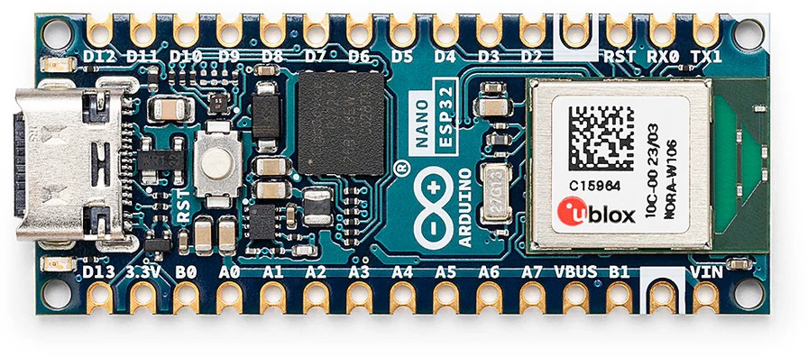  Arduino Nano 33 | 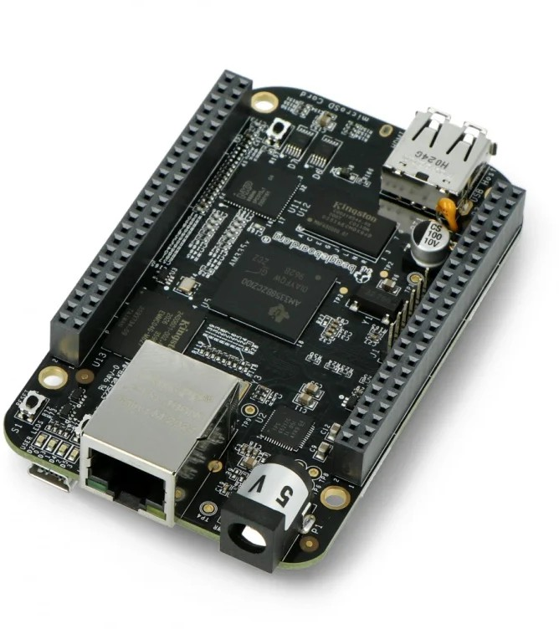  BeagleBone Black
Prcosseor | Quad-core ARM Cortex-A72 | Dual-core | 1GHz ARM  Cortex-A8
RAM | 2–8 GB | 0.5–0.1 GB | 0.5–4 GB
Storage | eMMC / microSD | Very limited onboard flash | eMMC / microSD
Connectivity | Wi-Fi, Ethernet, Bluetooth | Wi-Fi & Bluetooth Low Energy (BLE) | Ethernet, Wi-Fi
Price | High | Low | Moderate

Reason for choosing Raspberry Pi 4:
The Raspberry Pi 4 is chosen for its balance of performance, connectivity, and affordability, making it suitable for IoT-focused educational activities.

Cable

Model | 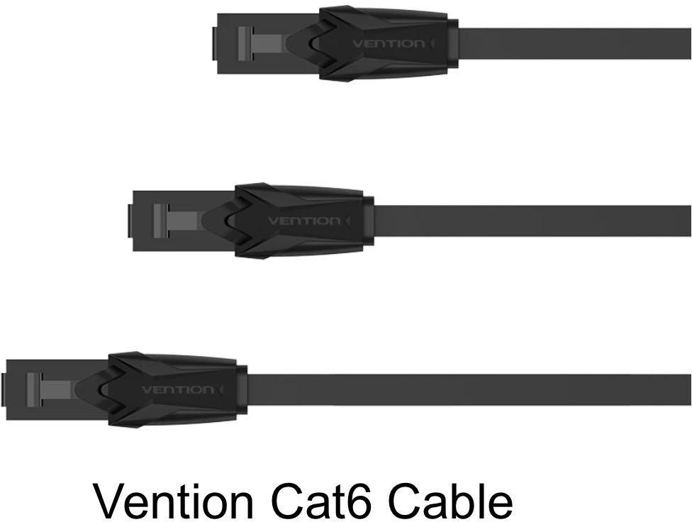 | 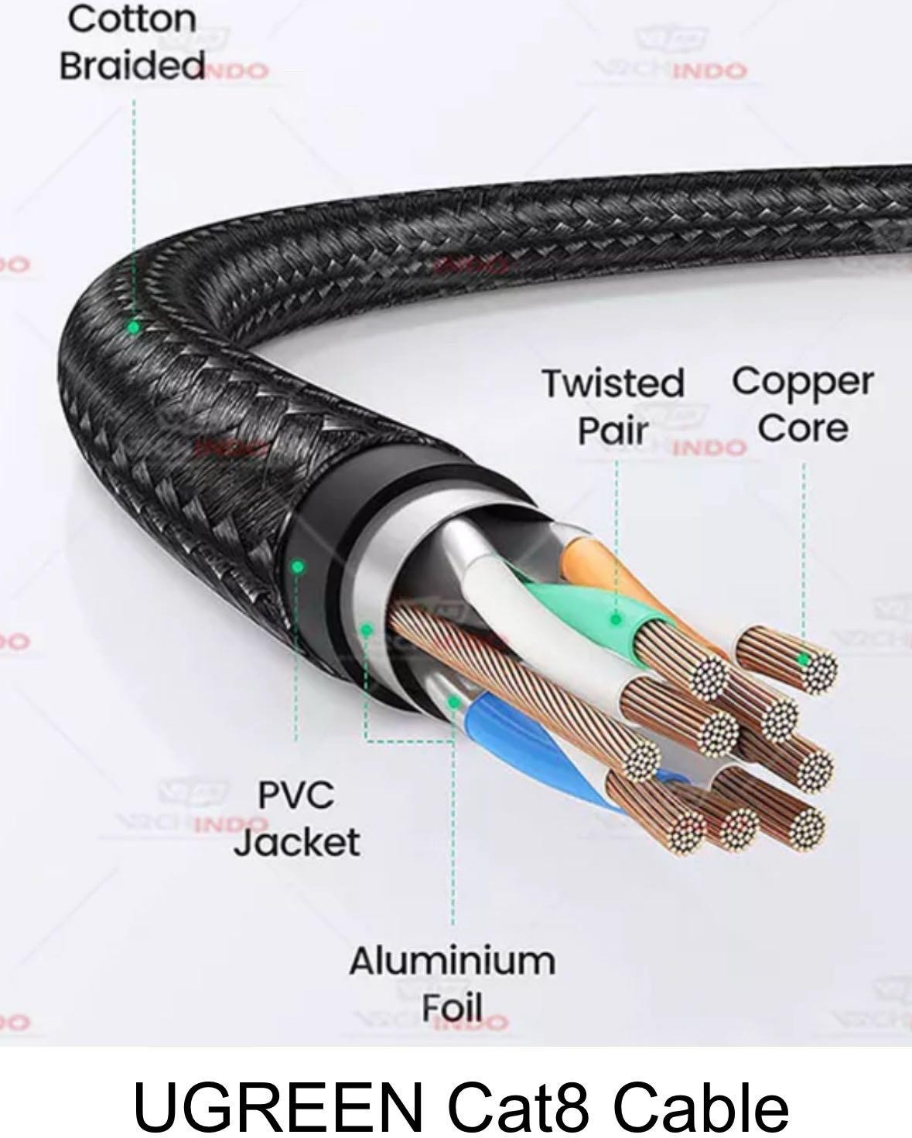 | 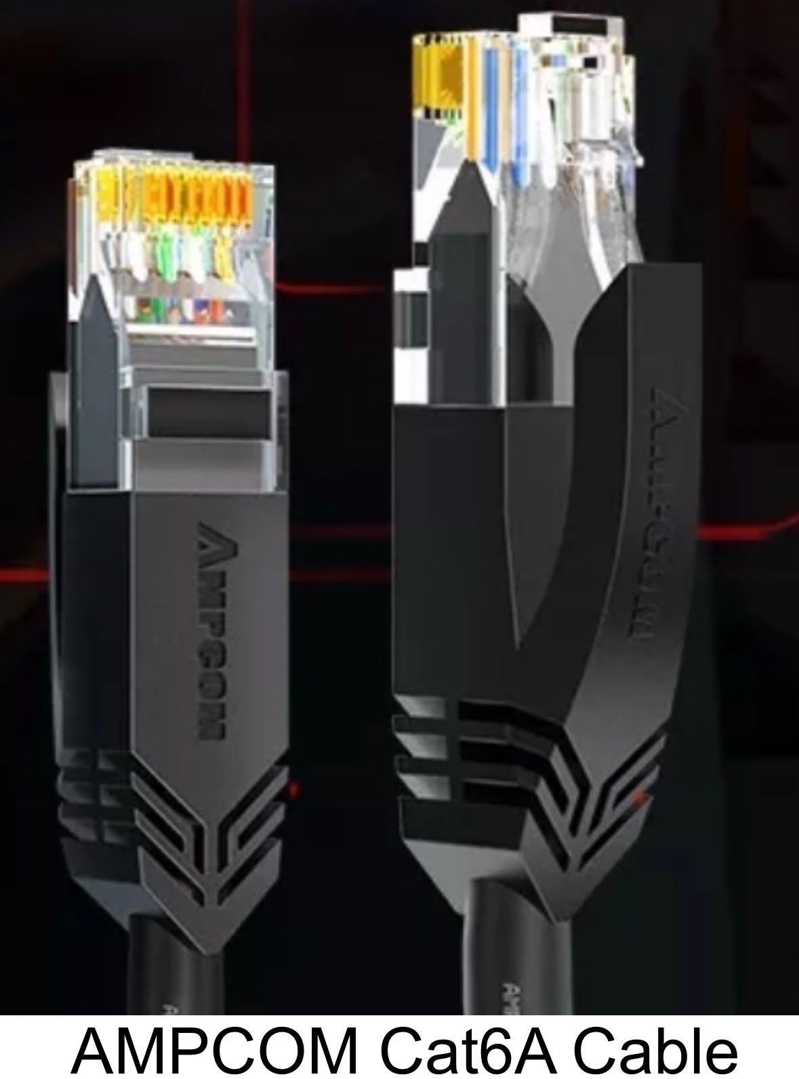
Bandwidth | 250MHZ | 2000MHZ | 500MHZ
Jacket material | PVC | PVC | LSZH
Transmission speed | 1000Mbps | 40000Mbps | 10000Mbps
Price (RM) | 23.63 (Link) (20m) | 155.02 (Link) (20m) | 87.40 (Link) (20m,UTP)

Reasons for choosing Vention Cat6 Cable:
Although the AMPCOM Cat6A and UGREEN Cat8 Cables offer higher performance, Vention is significantly cheaper. Since Cat6 already meets the classroom network requirements, Vention Cat6 Cable is the most cost effective choice.

Optical Fiber

Model | 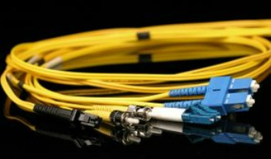  Singlemode OS2 (9/125 µm) | 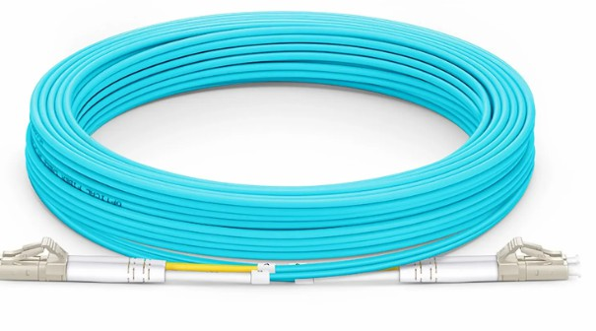  Multimode OM3 (50/125 µm) | 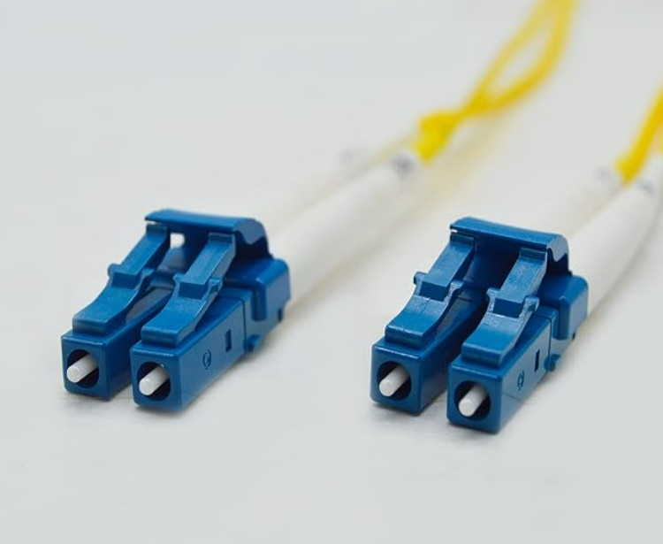  Corning Singlemode OS2 (9/125 µm) LC–LC
Supported Speed | 1–10+ Gbps | Up to 10 Gbps | 10–40 Gbps
Transceiver Type | SFP / SFP+ (LX / LR) | SFP+ 10G-SR | SFP+ / QSFP
Typical Distance | Long distance (km) | Indoor building (≤300 m) | Long distance (km)
Reliability | Very High | High | Extremely High
Price (RM) | 51 RM (20m) (Link) | 69 RM (20m) (Link) | 80 RM (20m) (Link)

Reason for Choosing Multimode OM3 (50/125 µm):
The OM3 multimode fiber optic cable was chosen because it provides enough performance for internal building networks at a reasonable cost. It supports speeds up to 10 Gbps, which is suitable for connecting the core switch to the access switches used in the project. The cable is easy to install, reliable, and appropriate for use within a single academic building without adding unnecessary complexity or extra cost.

Desktop Computer

Model | 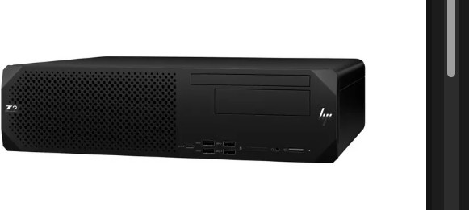  HP Z2 Tower G9 Workstation | 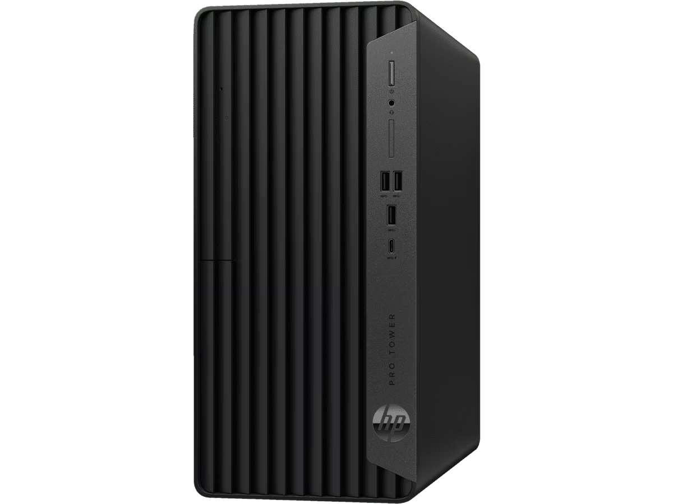  HP ProDesk 400 G9 PCI | 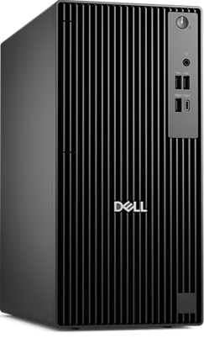  Dell OptiPlex 7010
CPU | Intel Core i7-13700 (13th Gen) | Intel Core i5 (12th Gen) | Intel Core i5/i7 (13th Gen)
RAM | 32 GB DDR5 | 8-16 GB | 16 GB
Processor  performance | High-end workstation performance, suitable for heavy multitasking, simulation, VM hosting, development work, rendering and  long-duration workload | Strong enough for multitasking, moderate virtualization, simulations | High performance that can handles heavier workloads, VMs, simulation, embedded lab tasks
Storage | 1TB NVMe SSD | 256 - 512 GB SSD | 512 GB SSD
Price (RM) | 6820 Link | 3137 Link | 3648 Link

Reason for choosing HP Z2 Tower G9 Workstation:

This workstation is chosen because it offers significantly higher performance compared to standard desktop PCs. With an i7 13th Gen processor, 32GB RAM, and 1TB NVMe SSD, it can handle heavy workloads, simulations, VM environments, coding, rendering, and research tasks efficiently. It ensures long-term reliability and is ideal for lab usage and future scalability.

Monitor

Model |   AOPEN 21.5” Full HD |   Acer 23.8” IPS Full HD | 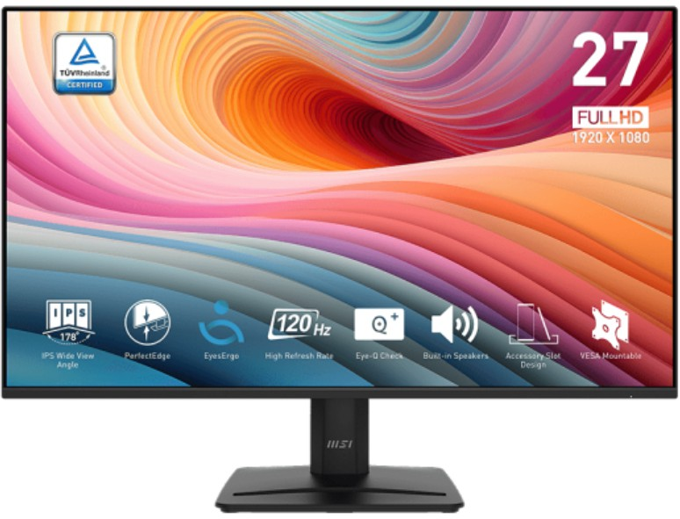  MSI PRO MP275 27”
Resolution | 1920 x 1080 (Full HD) | 1920 x 1080 (Full HD) | 1920 x 1080 (Full HD)
DisplayPort / HDMI / VGA | Likely VGA + HDMI (basic) | HDMI + DisplayPort (or VGA on some) | HDMI + DisplayPort, maybe DVI depending on model
Screen size | 21.5” | 23.8” | 27”
Panel Type | TN or VA | IPS | IPS
Response / Refresh rate | 60-75 Hz | 60-75 Hz | 100-120 Hz
Colour / Viewing | Basic, for text / code | Good for text, diagrams, code | Very good for diagrams, visual simulation, multitasking
Price (RM) | 246 Link | 319 | 372 Link

Reason for choosing Acer 23.8” IPS Full HD:
It provides the best visual clarity for coding, network diagrams and embedded work at an affordable cost. The IPS panel ensures students get wide viewing angles and consistent colour accuracy, which is crucial when multiple users view the same screen in lab environments. At only RM319, it provides excellent value without sacrificing screen quality or reliability.

Keyboard & Mouse

Model | 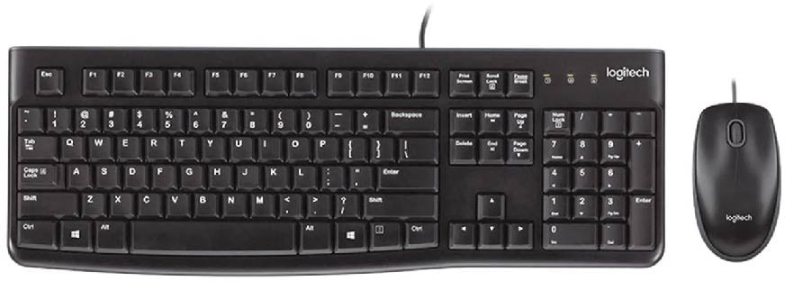  Logitech MK120 wired Keyboard + Mouse Combo | 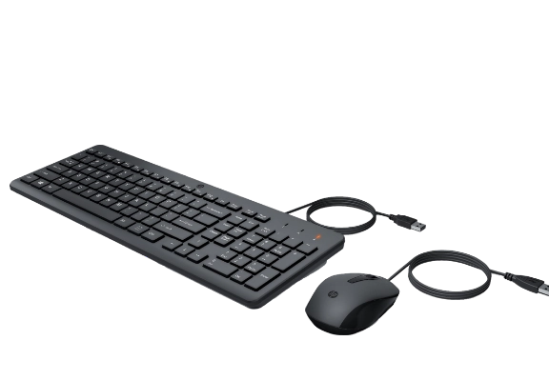  HP Wired Keyboard  + Mouse Combo | 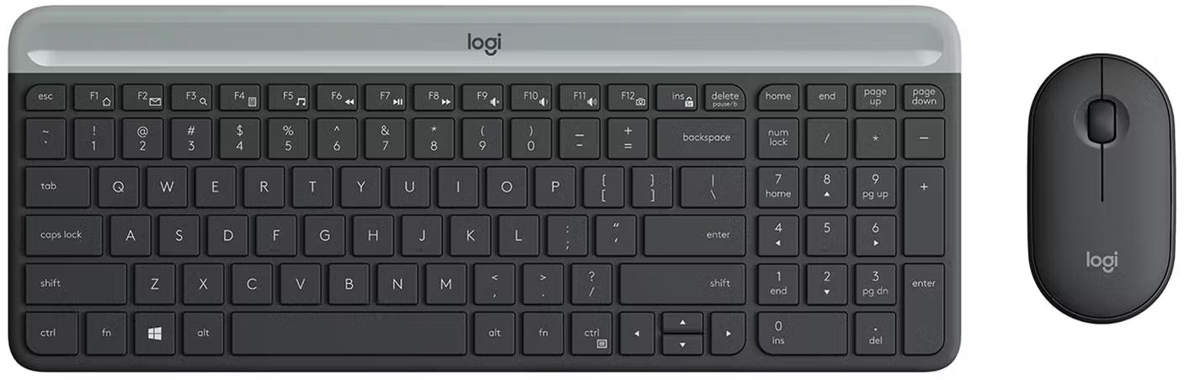  Logitech MK470
Battery Life | N/A (wired) | N/A (wired) | Keyboard battery - 24 months (depends) Mouse - 12 months (depends)
Mouse DPI / sensitivity | Standard optical, good for general tasks, not gaming | Standard office optical DPI (around  ~ 1000) | Slightly better / more precise, but still office- use (may be around 1000-1600)
Connectivity | USB wired | USB wired | Wireless (USB receiver)
Durability / Maintenance | Very low maintenance, no battery worry | Low maintenance, no battery worry, reliable for  long-term lab use | Need battery replacement / recharging, slightly more maintenance
Price (RM) | 59 Link | 66 Link | 269 Link

Reason for choosing HP Wired Keyboard + Mouse Combo:
It offers excellent durability and zero maintenance, which is necessary in a computer lab with 30-36 workstations. Wired peripherals ensure stable connectivity, no battery replacement and minimal user complaints. At RM 66, it is cost-effective while still being reliable for daily academic use.

Devices and Cost Breakdown

Category | Device | Qty | Unit Price (RM) | Total Price (RM)
Router | Cisco ISR 4321 | 9 | 9533 | 85797
Core Switches | Cisco Catalyst 9300 | 2 | 15044 | 30088
Access Switch | Cisco Catalyst 9200 | 7 | 9820 | 68740
Wireless Access Point | Cisco 1850 / 9115AX | 13 | 2207 | 28691
Firewall | Cisco Firepower 1010 NGFW | 1 | 10000 | 10000
Camera | HikvisionDS-2CD1043G2- LIU | 6 | 329 | 1974
Projector | Optoma HD28e | 6 | 2909 | 17454
Screen | Manual pull-down screen | 6 | 216.76 | 1300.56
Printer | HP LaserJet Pro M404dn | 2 | 1500 | 3000
IOT Devices | Raspberry Pi 4 | 30 | 300 | 9000
Desktop computer | HP ProDesk 400 G9 | 132 | 6820 | 900240
Cable | Vention Cat6 Cable | 160 | 23.63 | 3780.8
Optical Fiber | Multimode OM3 | 1 | 69 | 69
Monitor | Acer 23.8” IPS Full HD | 132 | 329 | 43428
Keyboard & mouse | HP Wired Keyboard + Mouse Combo | 132 | 66 | 8712
Overall Total |  |  |  | 1,212 274.36

Reflection Questions

- Are you surprised by the prices? How were you surprised?

Yes, the prices are somewhat surprising, especially when comparing enterprise-grade networking devices to desktop computers and peripherals. For example, a single Cisco Catalyst 9200 access switch costs RM 9,820, which is higher than many of the other components like desktops and monitors. The high cost reflects the enterprise-level reliability, throughput, and feature set of these devices. Similarly, routers like the Cisco ISR 4321 at RM 4,764 each and the Dell PowerEdge R550 servers at over RM 20,000 per unit highlight how specialized networking and server hardware can be much more expensive than standard computing devices. The surprise mainly comes from realizing that the cost of a few networking devices can account for a large portion of the total budget, even in an educational lab setting.

Have you ever considered cost as a factor for choosing networking devices?

Absolutely. Cost is a critical factor when selecting networking devices, especially for educational or lab environments where budgets are limited. While enterprise-grade devices like Cisco switches and routers offer high reliability, advanced security features, and better scalability, they come with high upfront costs. Balancing cost with performance is essential. For instance, a slightly lower-end router or switch may reduce initial expenditure but still meet the required throughput and reliability for student labs. Additionally, considering total cost of ownership — including maintenance, power consumption, and support contracts — ensures the chosen devices remain cost-effective over their lifespan.

What are the major differences between the same devices from different brands?
The major differences typically lie in performance, features, software, scalability, and cost. For example:

  - Routers: Cisco ISR 4321 provides strong enterprise-grade security and stable throughput, Juniper SRX345 offers higher scalability and redundancy, and TP-Link TL-ER7206 is more cost-effective but limited in features.
  - Switches: Cisco Catalyst 9300 and 9500 series differ in throughput, Layer 3 capabilities, and port configurations. Higher-end switches offer greater reliability, advanced features, and faster uplinks, while lower-end or competitor models may be sufficient for smaller deployments but lack advanced routing options.
  - Wireless Access Points: Cisco 1850/9115AX supports WiFi 6 and higher user capacity, Ubiquiti UAP-AC-Pro offers moderate speed and coverage, while TP-Link EAP245 is cheaper but supports fewer concurrent users.
  - Servers: Dell PowerEdge R550 provides high RAM capacity, dual CPU support, and virtualization readiness; HPE ProLiant and Lenovo ThinkSystem offer lower-cost options with limited expansion.
  - Printers: HP, Canon, and Brother devices differ in speed, energy efficiency, and reliability, affecting suitability for high-usage environments like student lounges.

Overall, the differences reflect trade-offs between cost, performance, scalability, and advanced features, making brand and model selection crucial depending on the lab or network requirements.

